How To Add Audio In PowerPoint

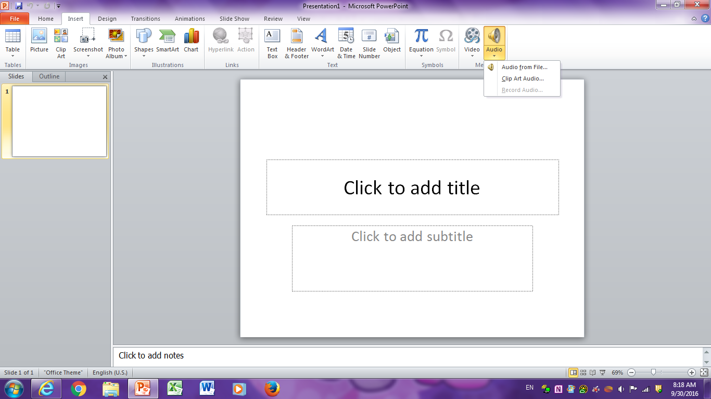

Drop the audio tab and it gives you three options: audio from file, clip art audio, and record audio. The record audio is the one you want if you want to speak but it will not work if you do not have a microphone plugged into your computer. When you know it will work you will be able to click on it to start recording.

Go under the insert tab

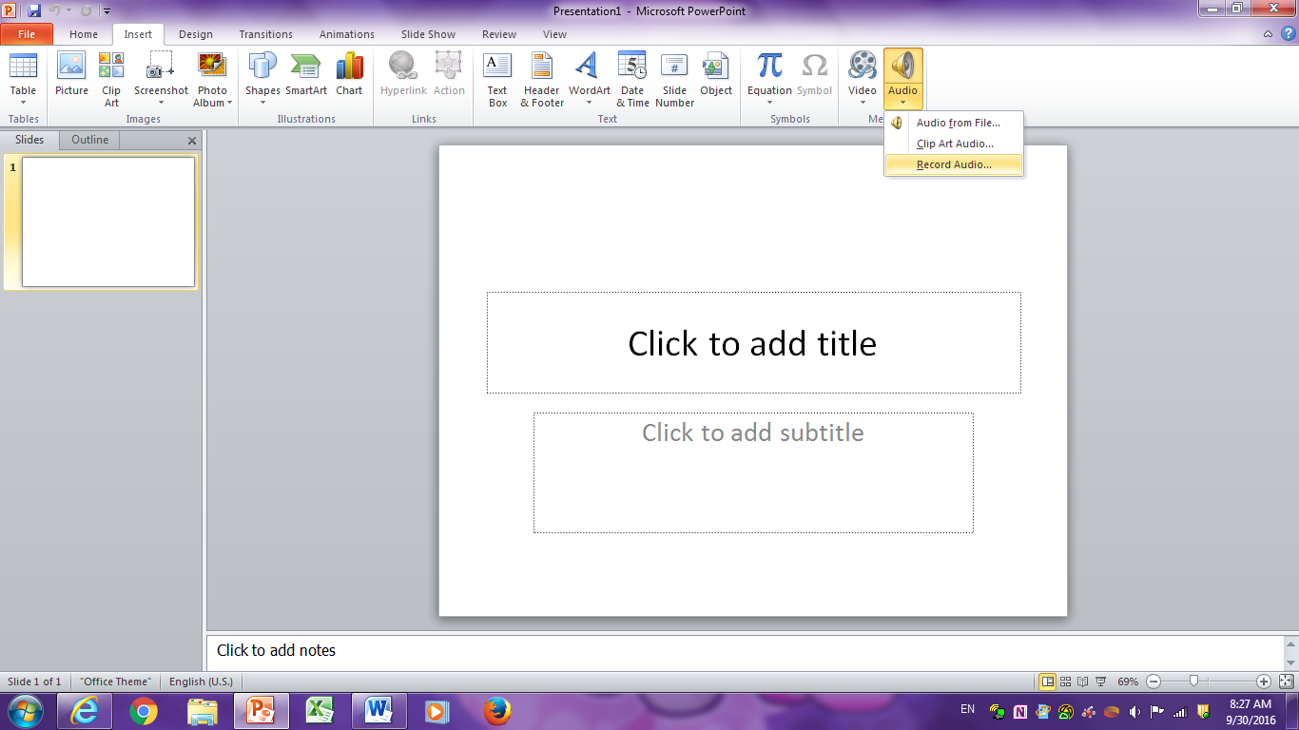

Now, if your mic is plugged in and it will not let you record you need to close PowerPoint and go back in. Now it should work.

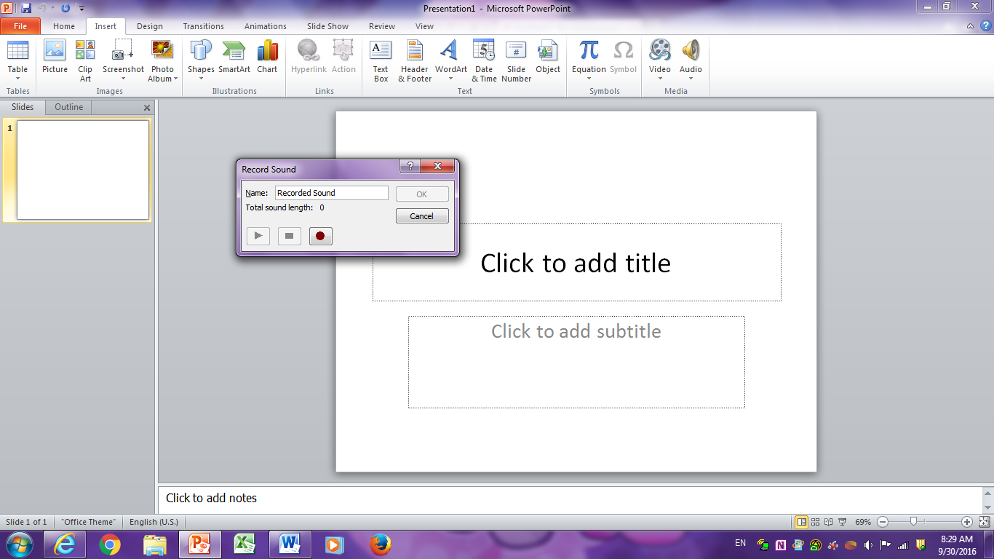

Once you click the record audio option you can start recording!