How to Use CheckMyWork
Step 1:
On your Home Page click the word Links located at the top.
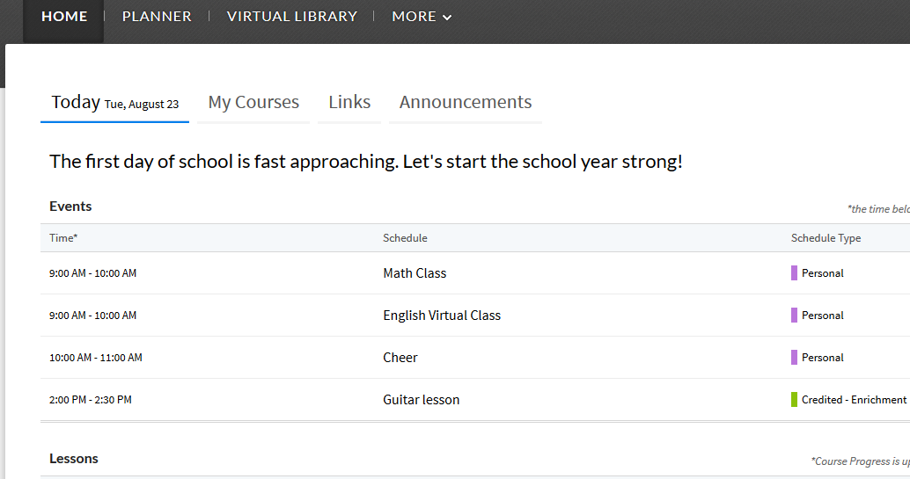

Step 2:
When the menu list appears, click CheckMyWork.
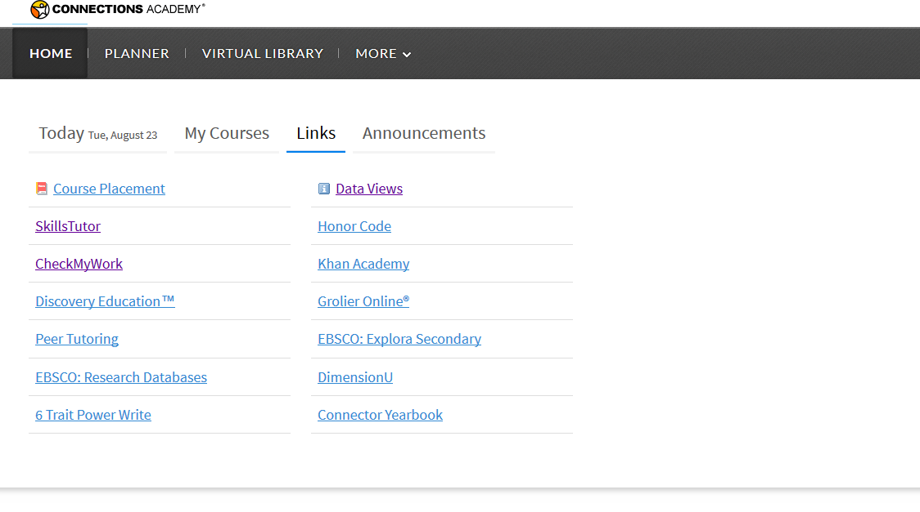

Step 3:
Here you will see your submission page.
- Choose the section you are submitting for by clicking the drop down arrow.
- Enter a title for the assignment (include Unit and lesson #)
- Either upload or copy and paste document in the MyWork section
- Click Submit
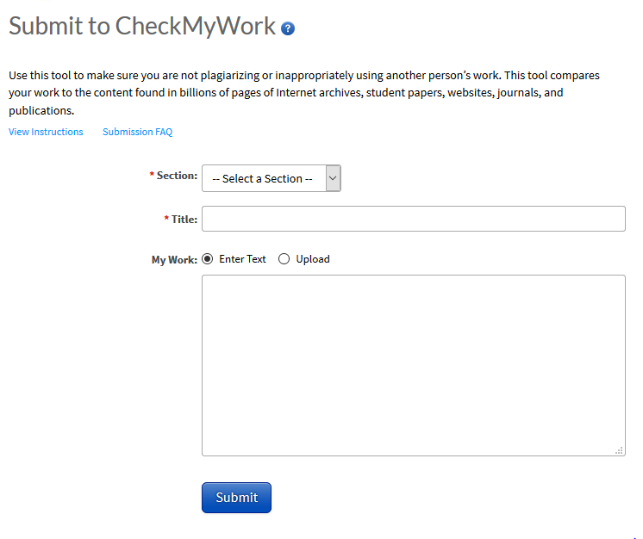

1

Step 4:
After submitting, an Originality Report link will come up. Copy this link and include with your test and portfolio submissions.
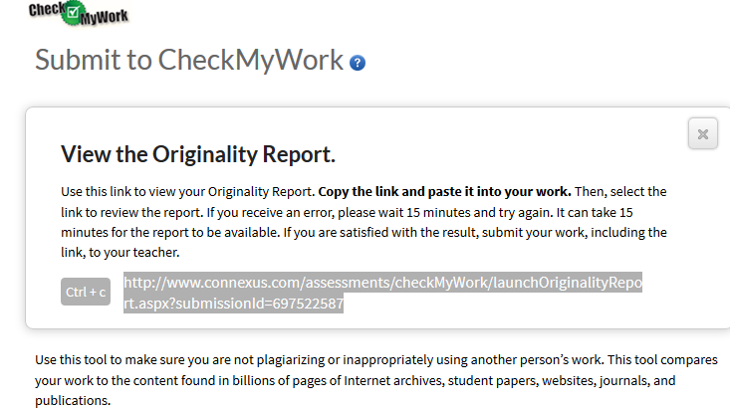

FYI – It takes several minutes for the report to be ready. If you get a strange message when you click on the link generated by CheckMyWork, it does not mean it didn’t work, it’s just not ready. Wait a few minutes and refresh the page. If a link was generated your submission worked!

